|  |  |
| --- | --- |
| Internship Project Title | Operations Management - Inventory Module using MERN Stack |
| Name of the Company | TCS iON |
| Name of the Industry Mentor | Debashis Roy |
| Name of the Institute | Madras Institute of Technology, Anna University |

|  |  |  |  |  |  |  |
| --- | --- | --- | --- | --- | --- | --- |
| Start Date | End Date | | Total Effort (hrs.) | | Project Environment | Tools used |
| 12-07-2022 | 16-07-2022 | | 23.5 | | VS Code, Windows, Firefox | NodeJS with Express, MongoDB Atlas, React, several npm packages |
| Milestone # | 1 | Milestone: | | Install and configure necessary software for the MERN Stack and complete action item 1 (Inventory submodule) | | |

**TABLE OF CONTENT**

* Acknowledgements
* Objective
* Introduction / Description of Internship
* Internship Activities
* Approach / Methodology
* Assumptions
* Exceptions / Exclusions
* Charts, Table, Diagrams
* Algorithms
* Challenges & Opportunities
* Risk Vs Reward
* Reflections on the Internship
* Recommendations
* Outcome / Conclusion
* Enhancement Scope
* Link to code and executable file
* Research questions and responses

# Acknowledgements

I thank TCS iON and the industry mentor for their guidance and support as well as for providing necessary information regarding the project.

# Objective

The objective of this project is to develop an automated software for Inventory Management module of Operations Management using MERN Stack.

# Introduction/Description of Internship

The method through which you keep track of your products across the whole supply chain, from purchase to manufacture to final sales, is known as an inventory management system (or inventory system).

It controls how you go about managing your company's inventory.

The goal of this project is to create an automated software system utilizing MERN Stack for the Operations Management Inventory Management module.

# Internship Activities

Some of the activities to be done during the internship include Pre-project test, activity report, interim project reports, final project report, project test.

# Approach / Methodology

1. Initially we create a backend server to serve and process requests from the client. The backend also communicates with the database and retrieves / stores information.
2. For this project I have used MongoDB Atlas which is a MongoDB hosted in the cloud.
3. We then model the data items to be stored in the database. This is done with the mongoose package which helps in data modeling for MongoDB.
4. The models are defined with mongoose schemas.
5. The frontend is made with React, a java script library for building user interfaces.
6. The frontend communicates with the backend by making get/post and other methods of requests to enable the various functions of inventory management
7. Items, item groups and adjustments are the data models created.
8. Each item belongs to an item group and adjustments can be made to the quantity/value of the items.
9. The adjustments made are viewable based on the time period selected.

# Flow diagram

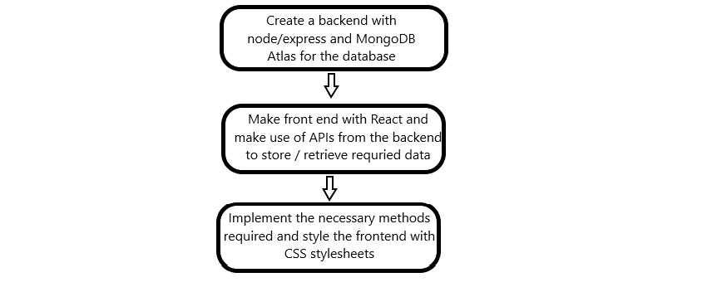

# Algorithms

We make use of certain comparisons in the application. For example, displaying the set of reports within a specific time period requires calculating the time period from which adjustments are to be shown and displaying only the valid adjustments.

Reflections on the Internship

I'm hoping that working as an intern with TCS ion will allow me to gain greater knowledge of the MERN stack!

# Enhancement scope

There is a lot of scope for improvement of this inventory module.

For instance, the inventory module can be enhanced by connecting with a store database and making real-time changes to the system instead of manually making adjustments.

# Link to code

GitHub repository with documents submitted till now and also the code for the project: <https://github.com/PragadeshBS/tcs-remote-internship>